**Restaurant analysis of Swiggy- Shreyas Reddy Kanthareddy**

**Task 1: Top 10 Areas with Most Restaurants:**

For the above task I have used stacked bar chart for analysing ( Y-axis : Area, X-axis: count of restaurants, and tooltip : city). It is observed that the number area with most restaurants is Rohini consisting of 257 which is in Delhi.

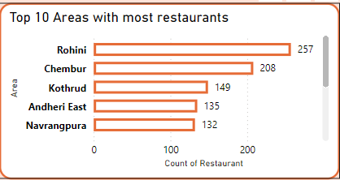

**Task 2: Most Popular Food Types Served by Swiggy Restaurants in Each City:**

Here I have created two tables “food type & restaurant count” and “max restaurant count” from the main source. The first table consists of city, food type , and restaurant count. The table consists of city and max restaurant count. Then using merge queries option , I have inner joined both the tables on city. After merging , stacked column chart is used for analysing.

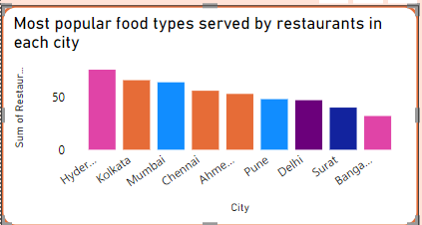

**Task 3: Top Rated Swiggy Restaurants (In Percentage):**

The data is analysed using a donut chart to get the percentage and count of the restaurants where the average ratings is above 4.50. Overall, there are 166 restaurants which has the average rating of 4.60 which occupies 51.23% in the chart.

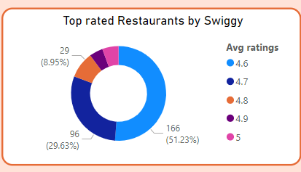

**Task 4: Correlation of Factors Affecting Average Rating, Task 11: Correlation Analysis :**

To analyse these two tasks, I have used Key influencers chart. In the “analyze field”, the value is “average ratings” and in the “explain by” field, the values are “area”, “delivery time”, “food type”, and “price”. After analyzing, the factors it is seen that the average ratings increase by 0.5 when the delivery time is 31 or less and increases by 0.23 average price is more than 540 rupees. The best area in the data is Anna Nagar (4.15: avg ratings) in Chennai. The worst area where the average rating is Matunga Wadala with 2.97 which is 28.4% lower than the Anna Nagar.

|  |  |
| --- | --- |
|  |  |



**Task 5: Correlation Between Restaurant Price and Average Rating:**

To analyze the correlation between restaurant and average rating, I have used scatter plot for better understanding. Delivery time has been used in values to measure the correlation. It is observed that the average price between 250 to 400 the average ratings vary from 3 to 4.5. There is not much relation between price and ratings in this dataset.

**Task 6: City-wise Restaurant Count:**

**Restaurant count in each city is analyzed using stacked column chart. Kolkata has the most number of restaurants with the count of 1346 and Surat has the least number of restaurants with the count of 512.**

**Task 7: Price Analysis:**

In this task I have used two different lines graphs to analyze. The first line graph tells us the maximum price of the restaurant and max average rating. The second line graph tells us the minimum price of the restaurant and min average rating. I have used a slicer to navigate between the cities and used a gauge to represent the average price across all the restaurants.

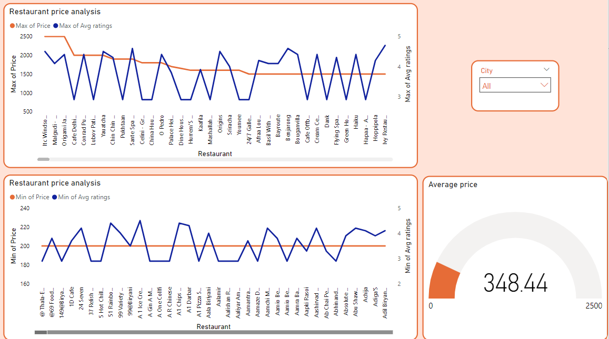

**Task 8: Delivery Time Analysis:**

Line chart has been used to analyze the task. By using average ratings as values, we have got the average delivery time as 53.97. The minimum delivery time is 20 minutes where the rating is 4.60 and 20 restaurants lie within this category. The maximum delivery time is 109 minutes where the rating 2.90 and 3000+ restaurants offer this poor quality.

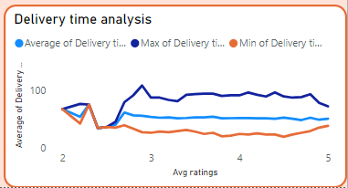

**Task 9: Cuisine Analysis:**

For cuisine analysis, I have used tree map chart for better explanation. A slicer has been added to search through each city to know the most favourite cuisine. Overall, the best and most favourable cuisine is “Indian” and followed by “Fast Food”.

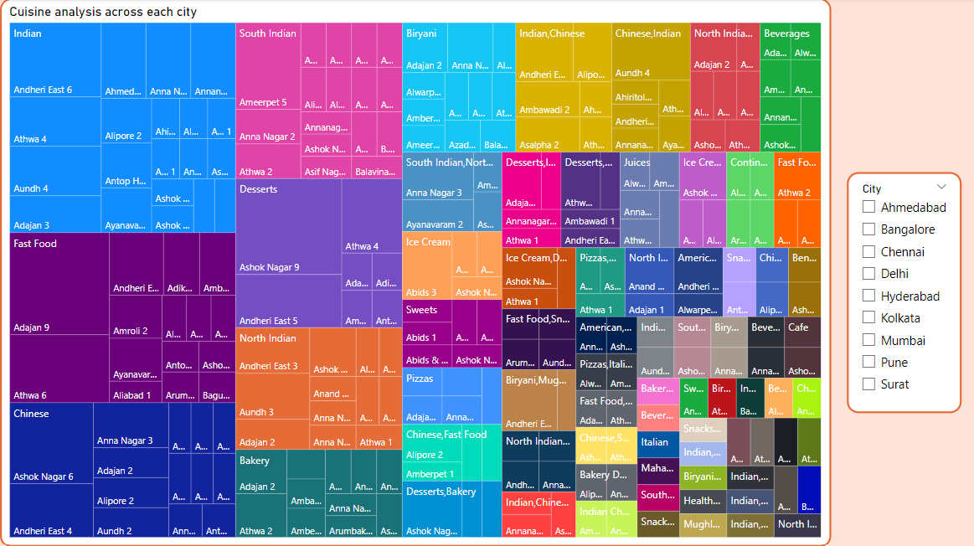

**Task 10: Area-wise Restaurant Analysis:**

For this task, we have to use the slicers (city and area) in the dashboard page to get the results. We can use area slicer to get the number of restaurants, to know the average delivery time and average ratings in the selected area.

**Task 11: It has been explained in the TASK-4.**

**Task 12: Customer Feedback Analysis:**

To analyze the customer feedback the values used are total rating and average ratings. When we hover over the average rating of 2.90, it is seen that 3279 customers given the feedback. Customers have given good rating to the restaurants which is between 4-4.5.

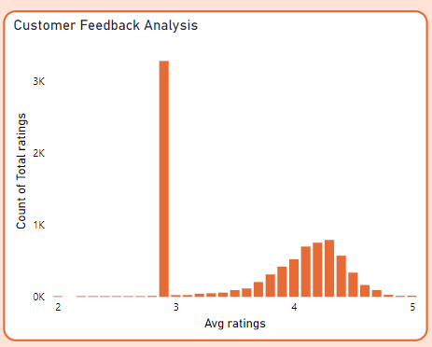

**Task 13: Geographical Mapping:**

This task is completed using Map chart to know the count of restaurants in each city.

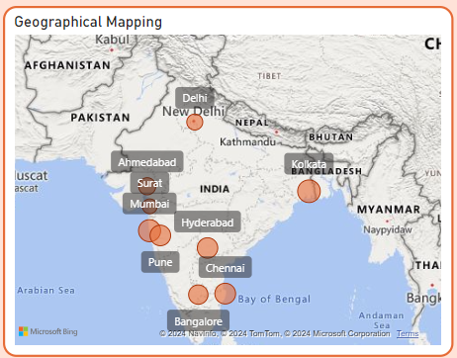

**Task 14: Business Recommendations:**

1. **Faster delivery option**:

According to the analysis it is seen that the average delivery time is 53.97 minutes. By hiring more employees for delivery, swiggy can accommodate more people in busy area so that the delivery partners can reach quickly to the restaurant to collect the order. This increases customer satisfaction.

1. **Improving customer satisfaction and ratings** :

Restaurants with high price with lower ratings can relate to this recommendation. By giving promotional discounts to the customers can increase in sales.

1. **Feedback given to underperforming restaurants**:

With the help of average ratings and total ratings, swiggy should take the initiative a feedback session to improve food and service quality.

1. **Collaborate with restaurants**:

Swiggy must collaborate with the restaurants which are high in average rating and lower in price. This not only increases the sales but also have customer loyalty.

1. **Monitoring low-ratings area**:

Swiggy must monitor the area which has high delivery time and low average rating. Address the problems and ensure they come up with a solution to get better market position.